Assignment – 3
Parsing of family tree using Knowledge-Base

Problem Statement:
The goal is to implement a system to parse a family tree using a knowledge base. The system should extract family relationships such as parent, child, sibling, and other kinship ties based on predefined rules stored in the knowledge base. The family tree will be built using logic-based inference mechanisms like Prolog-style querying or rule-based systems, and the relationships will be determined based on this structured knowledge.

Software used:
- Python 3.x
- Google Colab

Libraries and packages used:
- PyKE (Python Knowledge Engine): For knowledge-based reasoning
- NLP Libraries (optional): For natural language parsing of relationships
- Numpy/Pandas: For tabular data representation of the family tree
- RDFlib: To represent family tree data as an RDF graph (if using RDF format)
- Prolog:
- SWI-Prolog: A popular Prolog interpreter for knowledge representation and querying

Theory:
- Knowledge Base: A knowledge base is a collection of facts and rules that represent knowledge about a domain (in this case, family relationships). Facts are atomic assertions like “John is the father of Mary.” Rules define relationships based on facts, such as "If X is a parent of Y and Y is a parent of Z, then X is a grandparent of Z."
- Family Tree Parsing: Parsing a family tree means converting relationships (parent, sibling, cousin, etc.) into formal logical representations and then performing reasoning to answer queries like “Who is John’s grandparent?” or “Is Mary the cousin of Alice?”
Types of Relationships:
- Parent: A direct relationship where one person is a parent of another.
- Sibling: Two individuals who share at least one parent.
- Grandparent: The parent of one’s parent.
- Uncle/Aunt: A sibling of one’s parent.
- Cousin: The child of one's uncle/aunt.

Methodology:
- Define the Family Tree: Create a set of individuals and their relationships (e.g., John is the father of Mary). This data can be hardcoded or input as structured data (e.g., a CSV file or RDF format).
- Represent Knowledge in Logical Form:
- In Python: Use PyKE or custom logic to represent family relationships in the form of facts and rules.
- In Prolog: Use facts and rules to represent relationships.
Example:
Fact: parent (john, mary) means "John is a parent of Mary."
Rule: grandparent (X, Z): - parent (X, Y), parent (Y, Z) means "X is a grandparent of Z if X is a parent of Y and Y is a parent of Z."
- Query the Knowledge Base: Once the knowledge base is set up, use queries to determine relationships (e.g., "Who is the grandparent of John?").
- Parsing: Parse the input data (family tree) into a structured format. Depending on the format, use a parser to convert natural language or semi-structured data into logical assertions (facts).
- Answering Queries: Based on the logical rules and facts, answer complex queries about the family tree (e.g., "Who are the cousins of Alice?").

Advantages:
- Logical Representation: Easy to represent complex relationships in a structured way.
- Scalability: Can handle large family trees with hundreds of individuals efficiently.
- Query Efficiency: Allows quick querying once the knowledge base is set up.
- Reasoning Capabilities: Can infer indirect relationships (e.g., grandparents, cousins).

Limitations:
- Initial Setup: Setting up a complete knowledge base can be time-consuming.
- Complex Queries: Complex queries can require deep reasoning, which may become slow for large knowledge bases.
- Natural Language Parsing: If input is in natural language, parsing may become complex without proper NLP tools.

Applications with example:
- Genealogical Research: A knowledge base can be used to trace family lineages and answer complex queries about ancestry.
- Social Networks: Understanding and parsing relationships in social networks where connections between individuals are represented similarly to family trees.

Working / Algorithm:
Step 1: Define Family Facts: Input family relationships as a set of facts in the knowledge base.
Step 2: Define Relationship Rules: Write logical rules to define relationships like grandparents, siblings, cousins, etc.
Step 3: Parse Family Data: If family data is unstructured, write a parser to convert it into structured facts.
Step 4: Querying the Knowledge Base: Input a query about family relationships. The knowledge base will use the facts and rules to answer the query.
Step 5: Recursion and Backtracking (if needed): For more complex queries (e.g., finding all cousins), the system may need to recursively apply rules and backtrack to explore all possible solutions.
Step 6: Output the Results: Return the answer to the user.

Diagram:
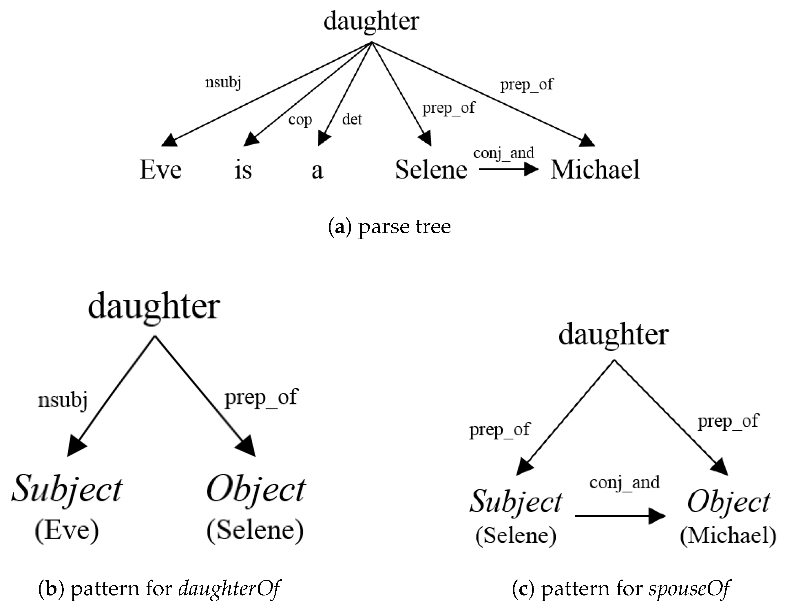

Conclusion:
The implementation of a Constraint Satisfaction Problem (CSP) using the Backtracking algorithm allows for solving a wide range of real-world problems, from scheduling to puzzles. While backtracking provides a simple and effective solution for small-scale problems, advanced techniques like constraint propagation and forward checking can significantly improve efficiency for larger or more complex CSPs. This assignment demonstrates how powerful CSPs are in AI applications, providing the groundwork for solving more sophisticated problems using optimization algorithms.

